**Matrices:**

Consider the matrix:

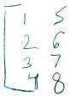



Above matrix can be represented as

This symbol means that the matrix is an element of the family of matrices having 4 rows and 2 columns.

**Vectors:**

Vectors are matrices with n rows but only one column.

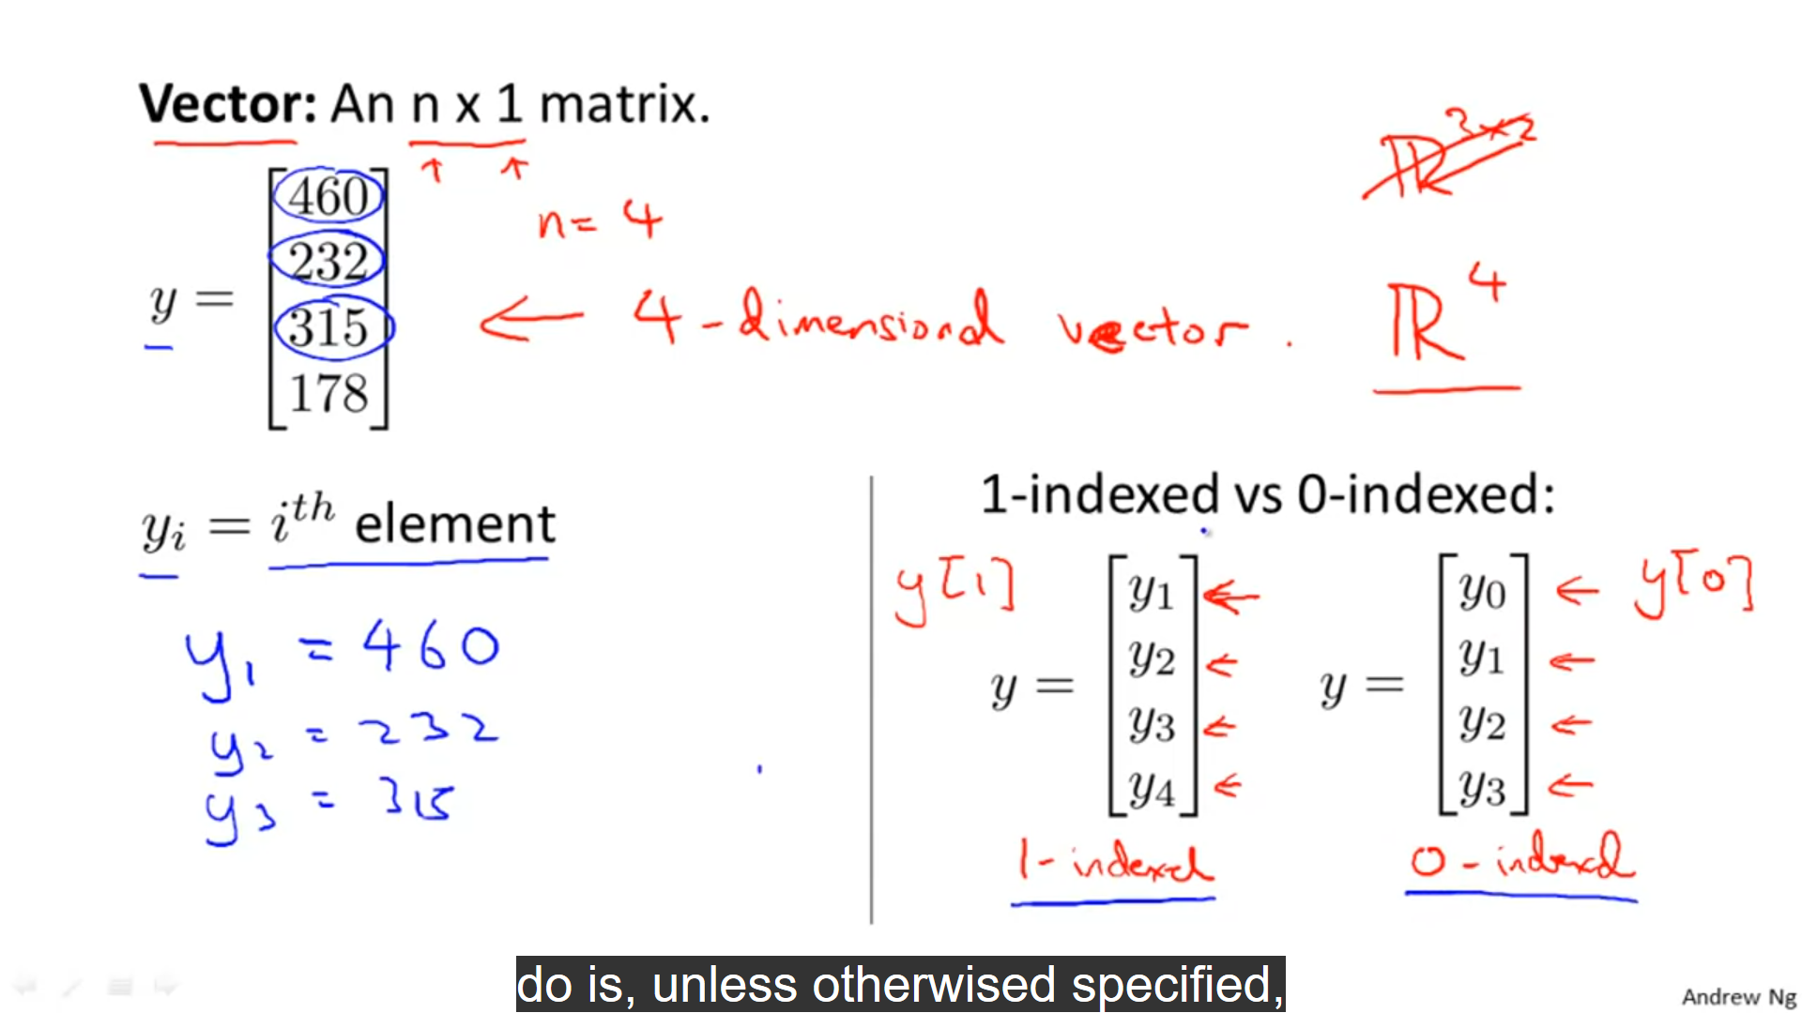

MATRIX ADDITION:  
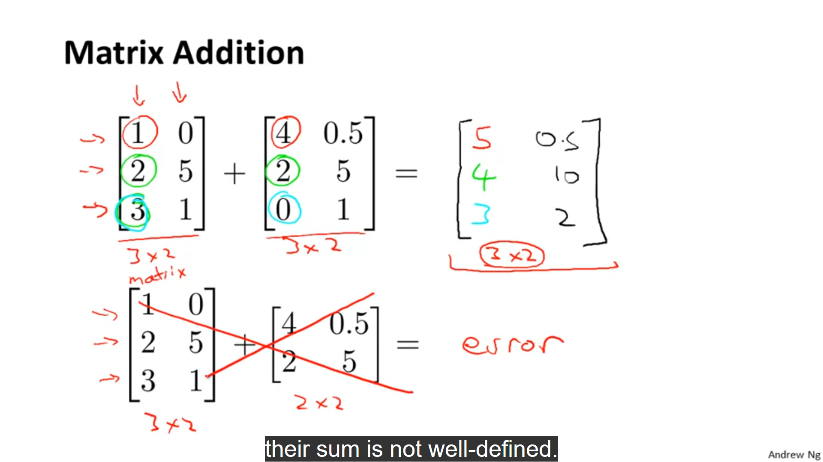

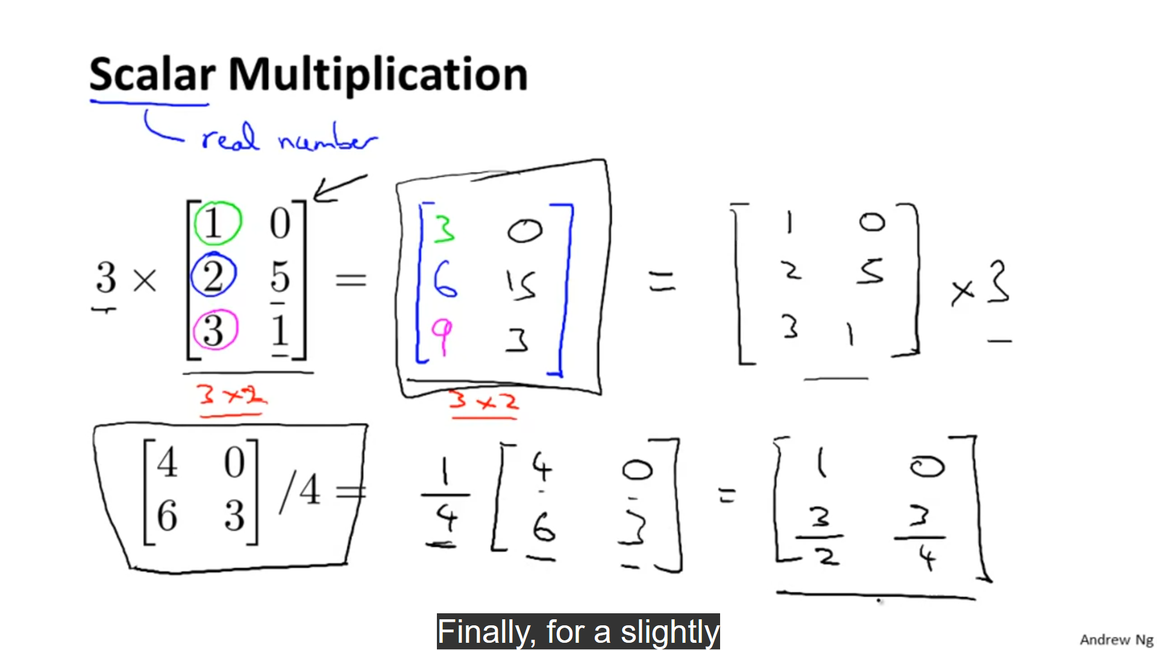

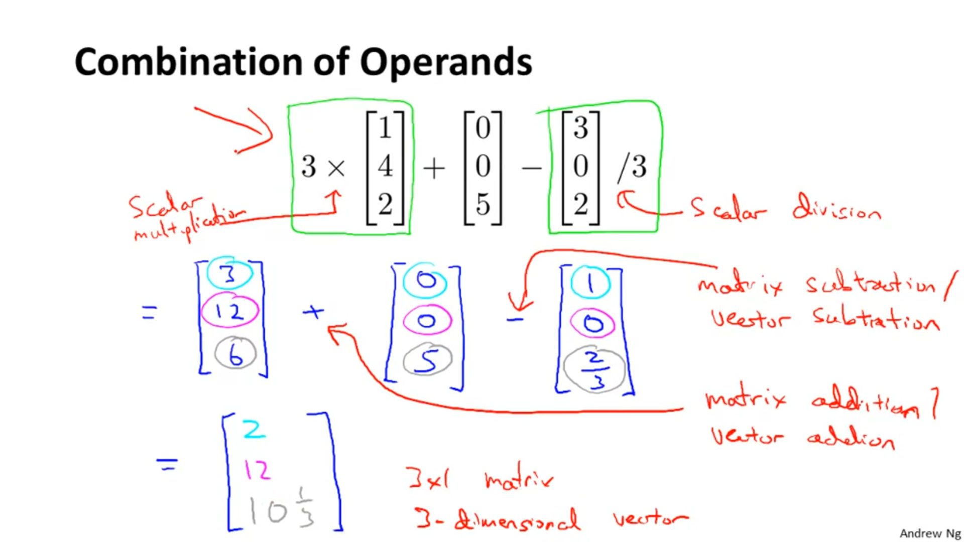

**Matrix vector Multiplication:** 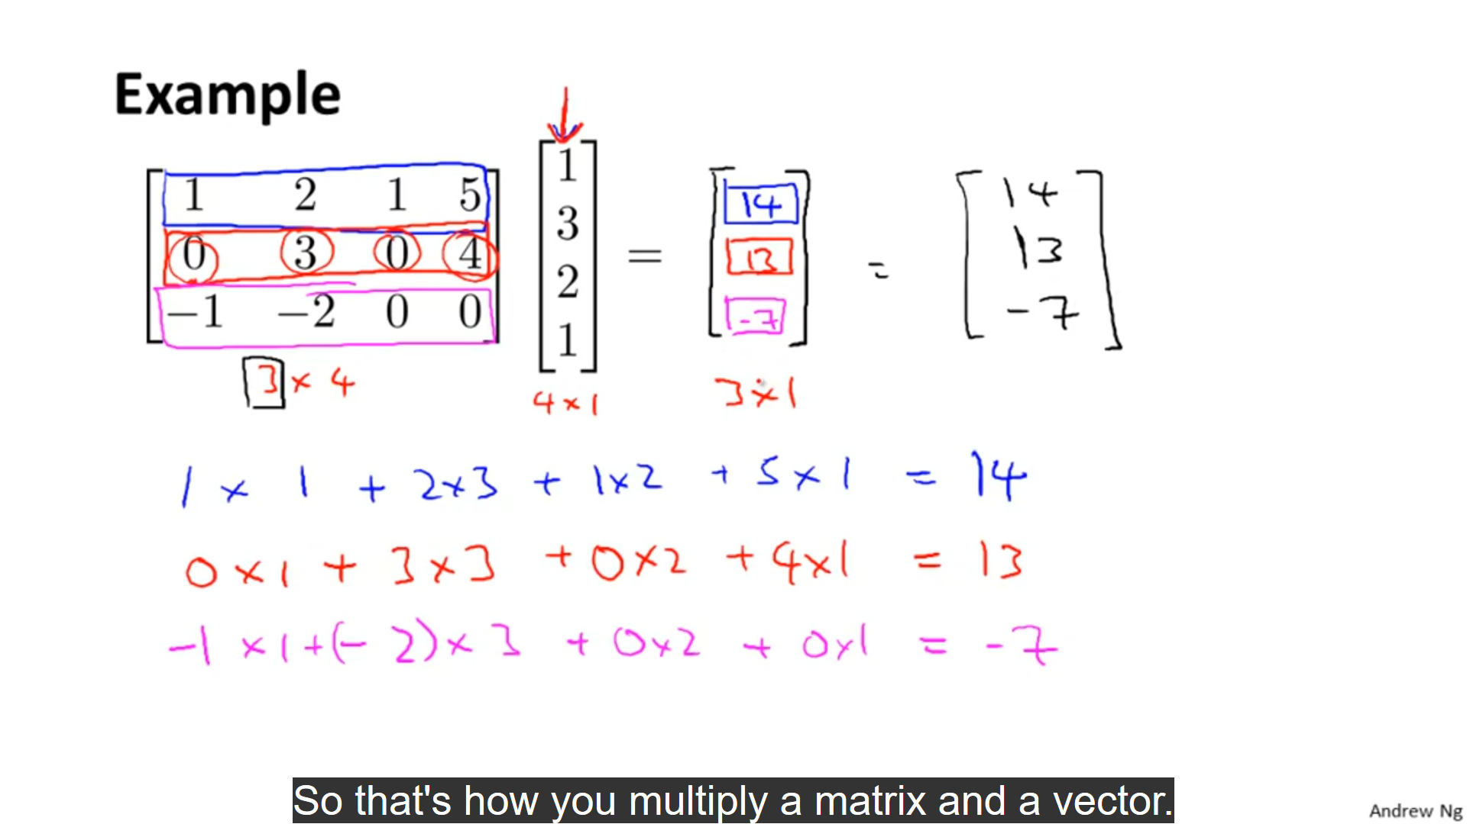

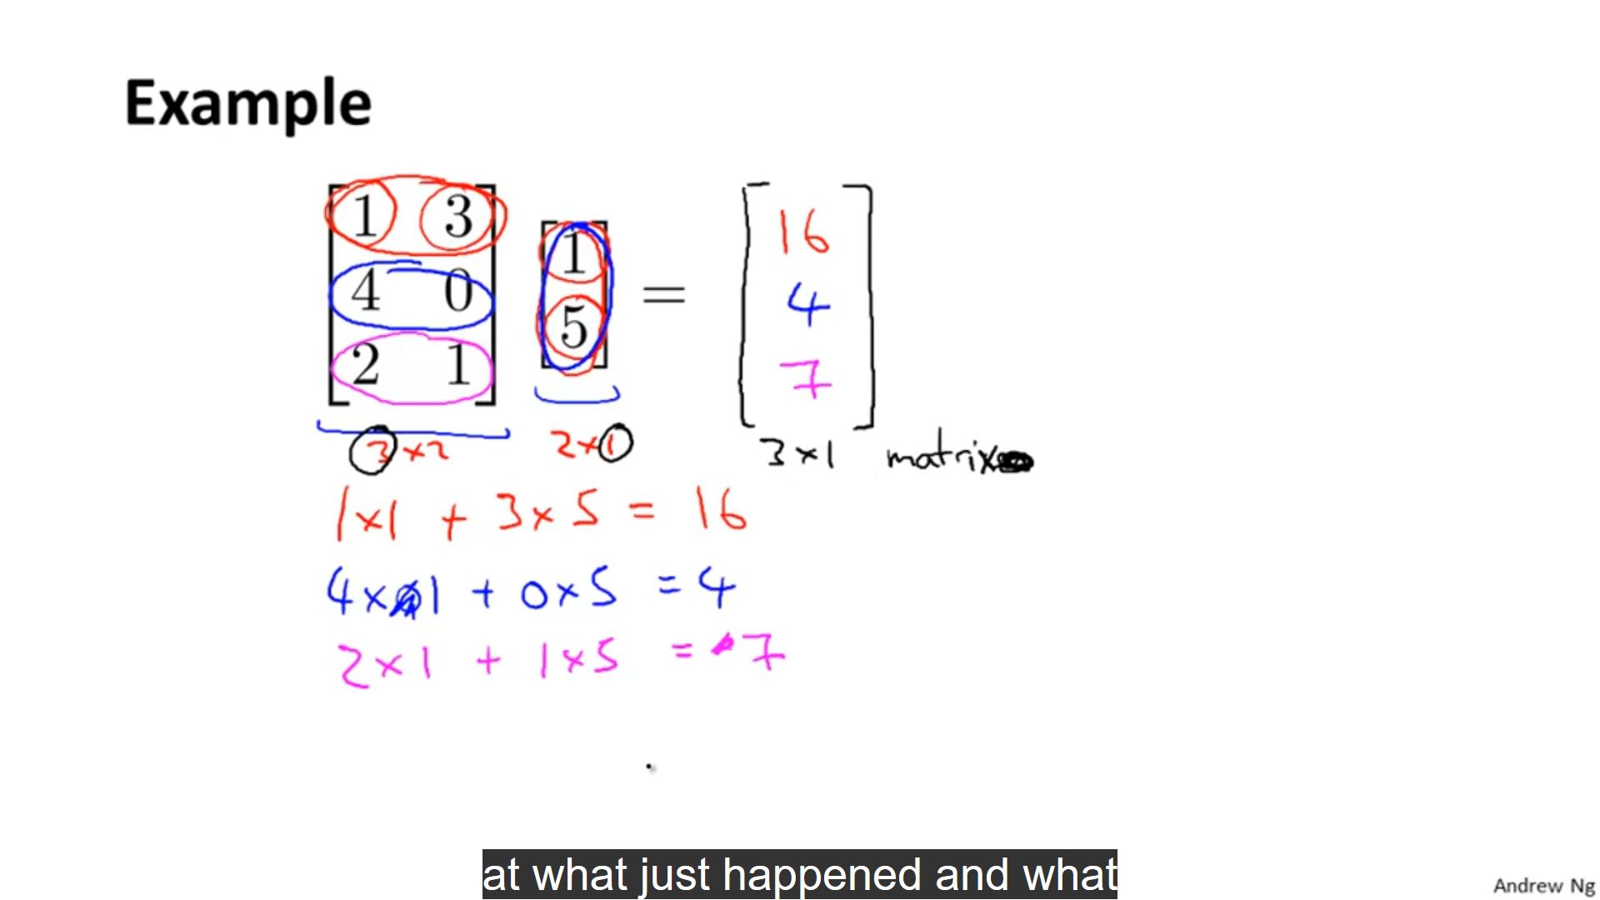

**Predicting house prices using matrix vector multiplication:**

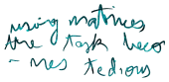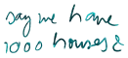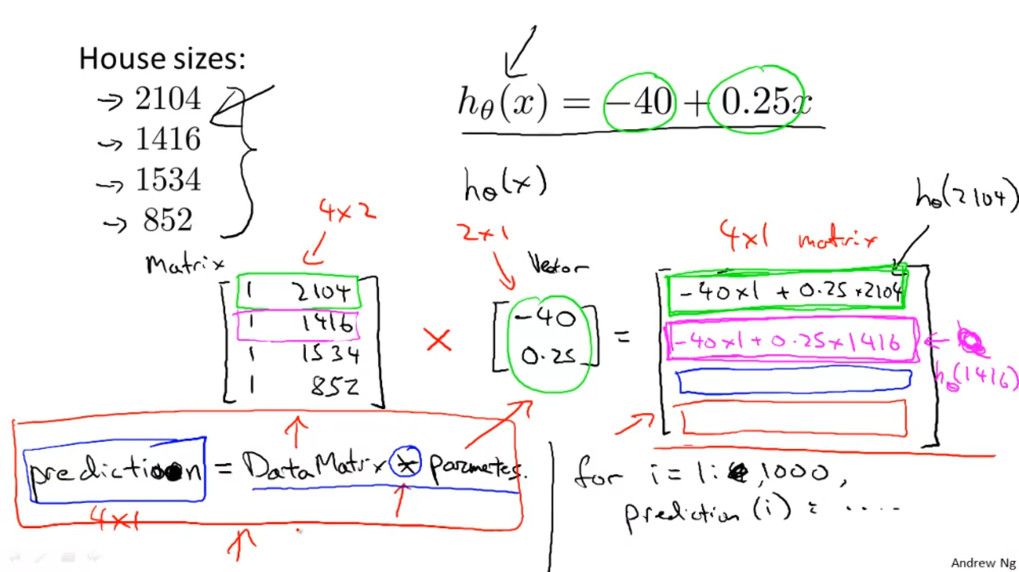

**Multiplying two MATRICES:**

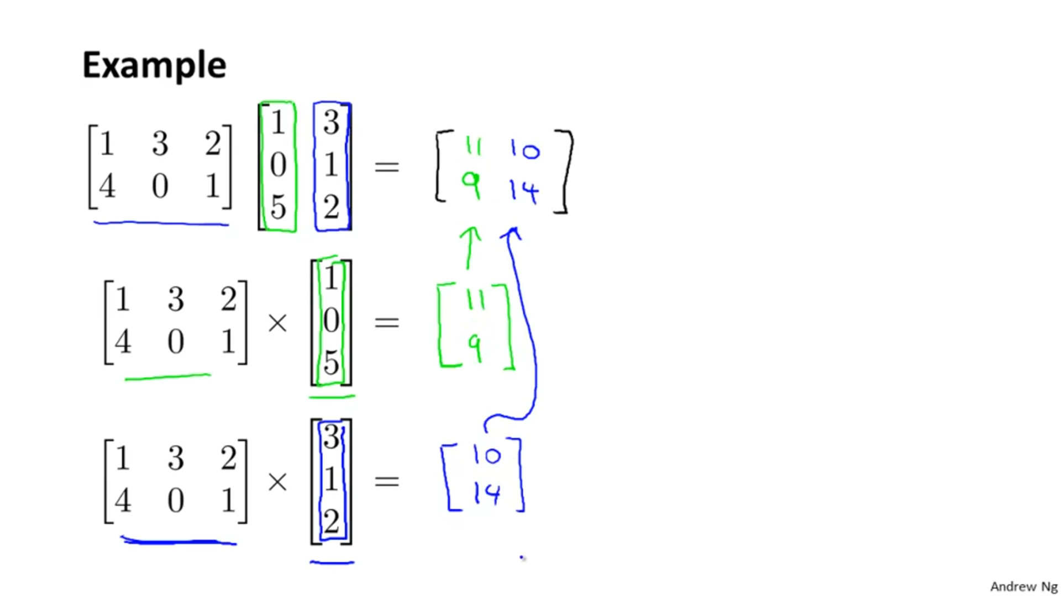

**Eg 2:**

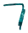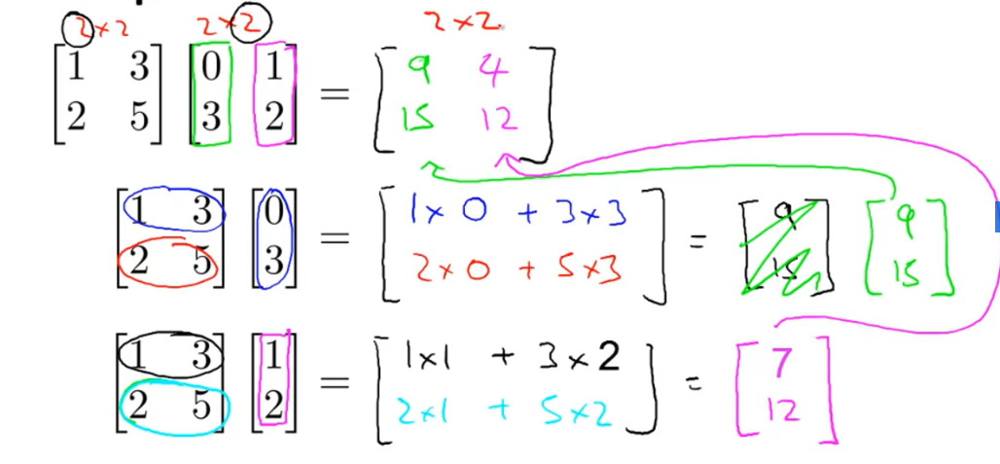

**Predicting Housing prices using 3 equations simultaneously:**

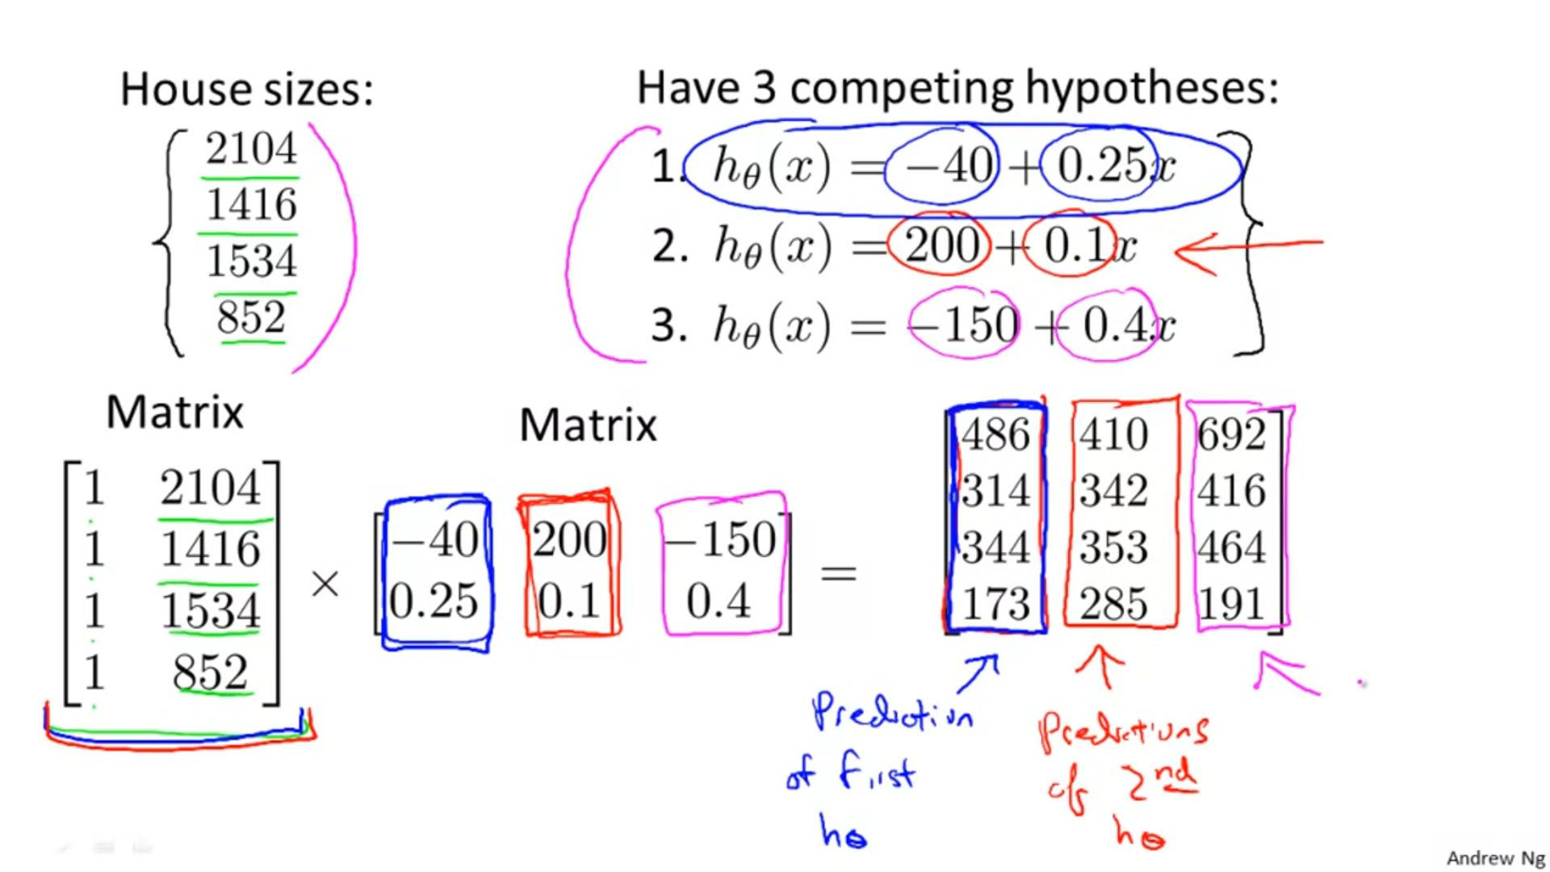

**Properties of Matrix Multiplication:**

**1. Matrix multiplication is not cummutative**

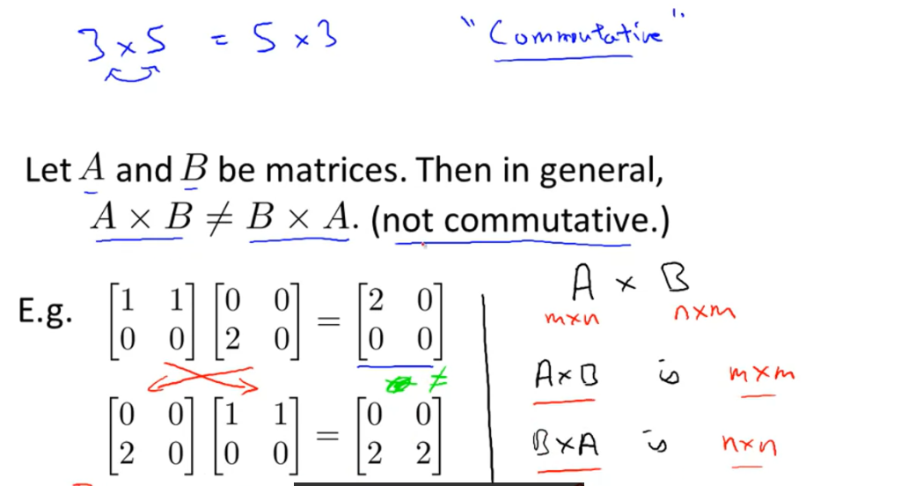

**Matrix multiplication is Assosciative:**

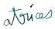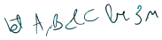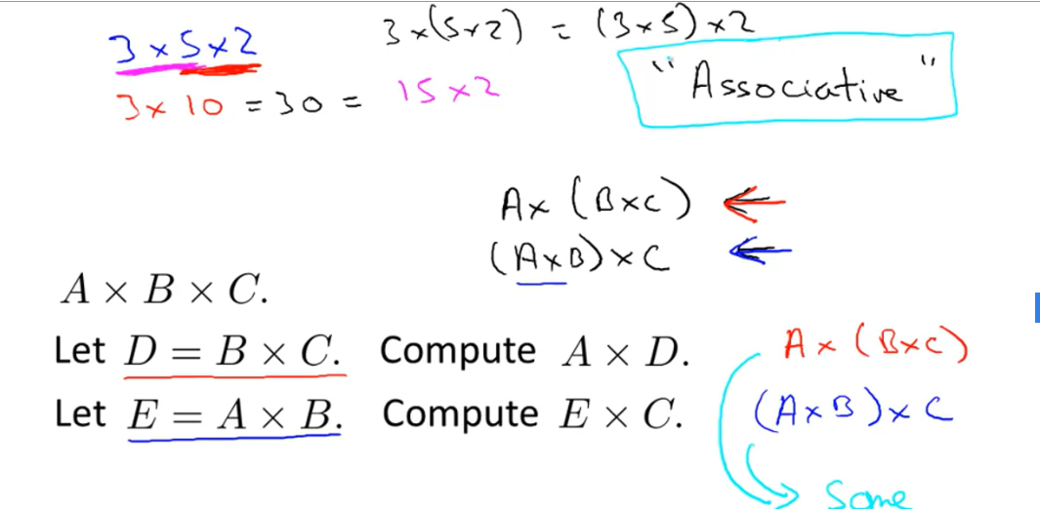

**Identity matrix:**

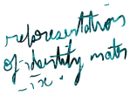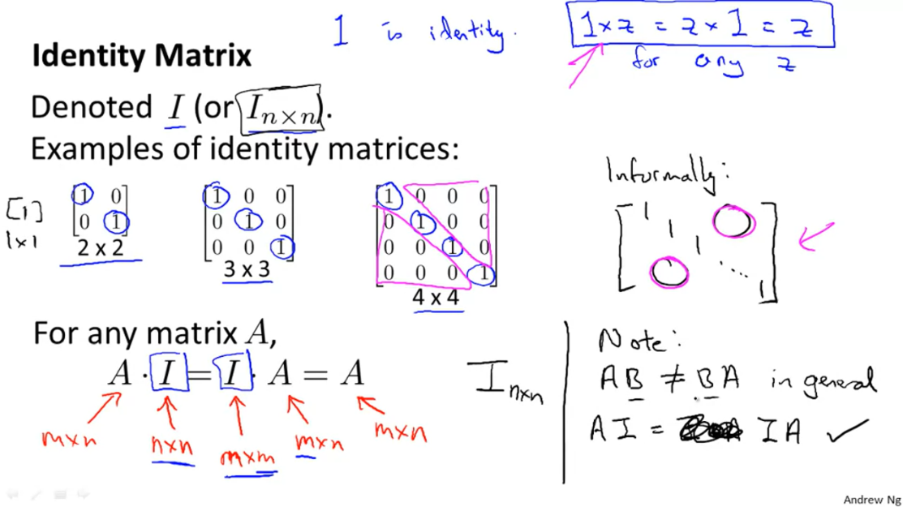

**Inverse of a Matrix:**

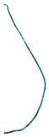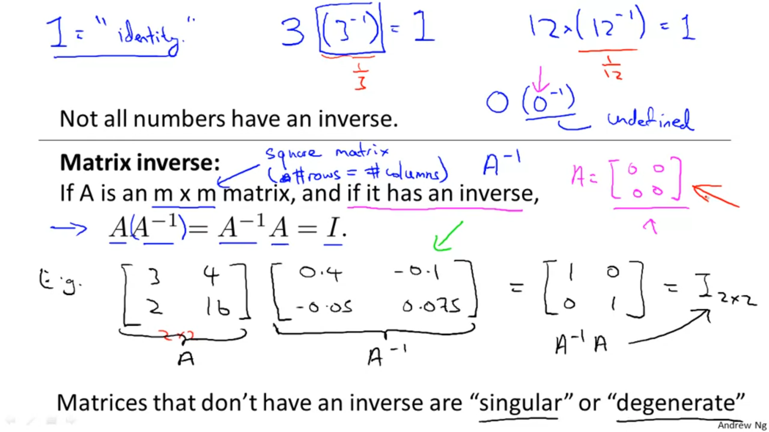

**Transpose of a Matrix:**

In transpose , rows become columns and columns become rows.

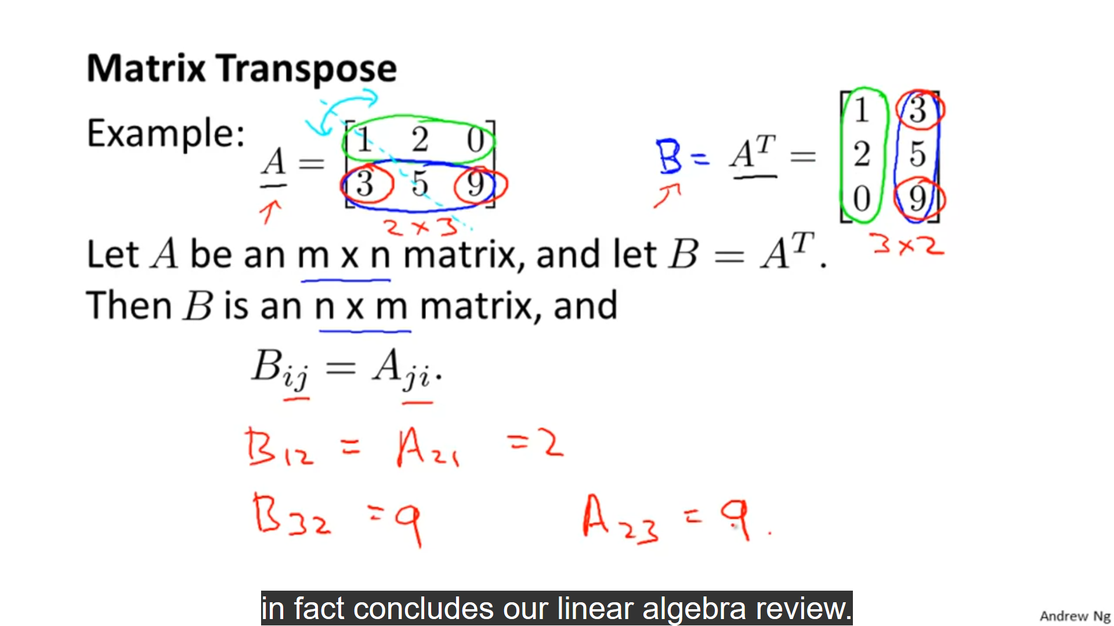

**Multivariate Linear Regression:**

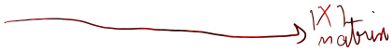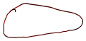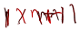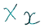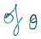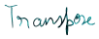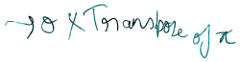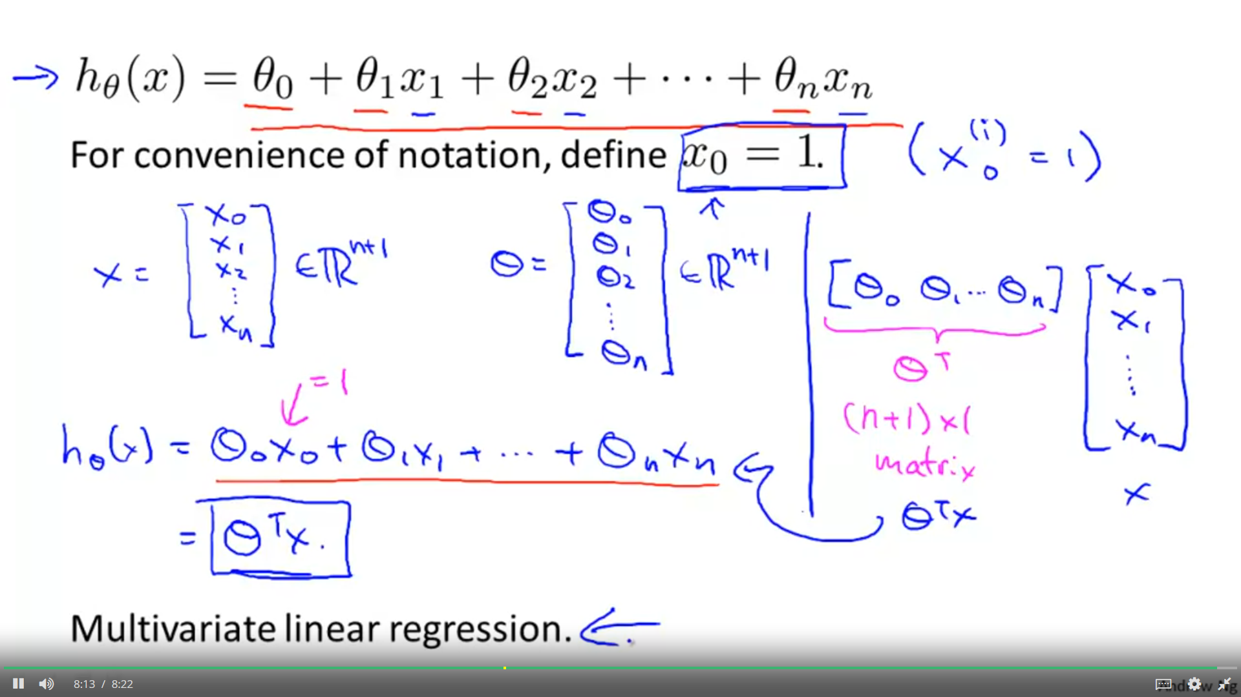

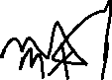

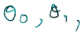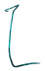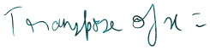

We assume x0­­= 1 so that we can form a matrix of x of n+1 terms from x0  to xn+1 .

